Problem statement: - A company has an automated Service Request system. All its customers can call into the help line number and the service request is logged into the system by the customer care executive. An automated Ticket id or Service Request Number (SR number) is generated. This Ticket id is shared with the customer. Once the request is successfully resolved, the customer service executive gives the customer a status call and closes the same on the system.

Other data points captured include

1. Entitlement- Type of Request
2. Impact- What is the impact on the customer’s business because of the problem
3. Billable – Customers can be on a Billable service plan OR on a Free service plan
4. Date Opened – Time stamp when the Service Request was put in the system
5. Closed Date - Time stamp when the Service Request was closed in the system

The Company wants to understand the average time it takes to resolve queries.

1. Does this average time vary by Impact ?
2. What is the data that should be used to make commitment on resolution time to customers for different Impact ?

Solution :-

/*SET WOORKING DIRECTORY */

LIBNAME A "/home/subhashini1/my_content"; **RUN**;

/*IMPORT DATA*/

FILENAME REFFILE "/home/subhashini1/my_content/Resolution time for Service request.csv" TERMSTR=CR;

**PROC** **IMPORT** DATAFILE=REFFILE

DBMS=CSV

OUT=WORK.RESOLUTION;

GETNAMES=YES;

**RUN**;

/*CHECK CONTENTS OF THE DATA*/

**PROC** **CONTENTS** DATA=WORK.RESOLUTION ; **RUN** ;

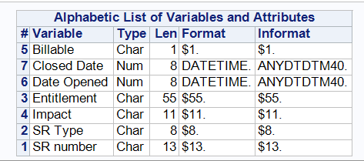

/* D = CREATE Y VARIABLE = CREATE RESOLUTON TIME */

**DATA** WORK.RESOLUTION;

SET WORK.RESOLUTION;

RESOLUTION_TIME = 'Closed Date'N-'Date Opened'N; **RUN**;

**PROC** **UNIVARIATE** DATA= WORK.RESOLUTION ;

VAR RESOLUTION_TIME; **RUN** ;

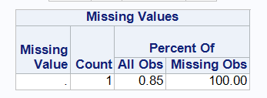

/* DROP 1 OBS WITH MISSING VALUE IN RESOLUTION TIME */

**DATA** WORK.RESOLUTION ;

SET WORK.RESOLUTION ;

WHERE RESOLUTION_TIME NE **.**; **RUN** ;

**PROC** **MEANS** DATA= WORK.RESOLUTION;

VAR RESOLUTION_TIME ; **RUN** ;

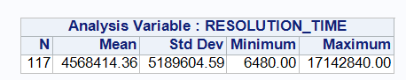

/* CONVERT RESOLUTION TIME INTO DAYS */

**DATA** WORK.RESOLUTION ;

SET WORK.RESOLUTION ;

RESOLUTION_DAYS= RESOLUTION_TIME /(**24**\***60**\***60**); **RUN** ;

**PROC** **MEANS** DATA= WORK.RESOLUTION;

VAR RESOLUTION_DAYS ; **RUN** ;

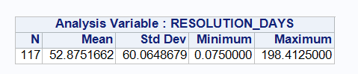

# Box plot

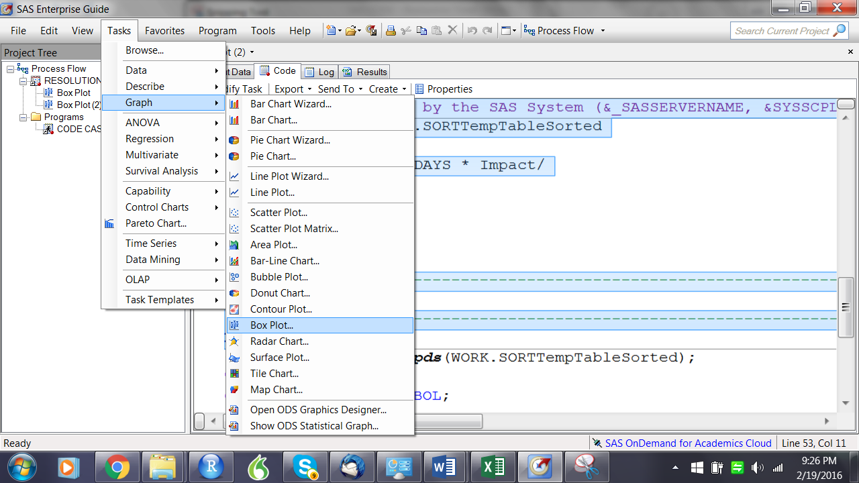

Auto code gets generated:-

/* -------------------------------------------------------------------

Code generated by SAS Task

Generated on: Friday, February 19, 2016 at 9:12:58 PM

By task: Box Plot (2)

Input Data: SASApp:WORK.RESOLUTION

Server: SASApp

------------------------------------------------------------------- */

%***_eg_conditional_dropds***(WORK.SORTTempTableSorted);

/* -------------------------------------------------------------------

Sort data set SASApp:WORK.RESOLUTION

------------------------------------------------------------------- */

**PROC** **SQL**;

CREATE VIEW WORK.SORTTempTableSorted AS

SELECT T.Impact, T.RESOLUTION_DAYS

FROM WORK.RESOLUTION as T

;

**QUIT**;

SYMBOL1 INTERPOL=BOX VALUE=CIRCLE

HEIGHT=**1**

MODE=EXCLUDE

;

Axis1

STYLE=**1**

WIDTH=**1**

MINOR=NONE

;

Axis2

STYLE=**1**

WIDTH=**1**

MINOR=NONE

;

TITLE;

TITLE1 "Box Plot";

FOOTNOTE;

FOOTNOTE1 "Generated by the SAS System (&_SASSERVERNAME, &SYSSCPL) on %TRIM(%QSYSFUNC(DATE(), NLDATE20.)) at %TRIM(%SYSFUNC(TIME(), TIMEAMPM12.))";

**PROC** **GPLOT** DATA=WORK.SORTTempTableSorted

;

PLOT RESOLUTION_DAYS * Impact/

VAXIS=AXIS1

HAXIS=AXIS2

;

/* -------------------------------------------------------------------

End of task code

------------------------------------------------------------------- */

**RUN**; **QUIT**;

%***_eg_conditional_dropds***(WORK.SORTTempTableSorted);

TITLE; FOOTNOTE;

GOPTIONS RESET = SYMBOL;

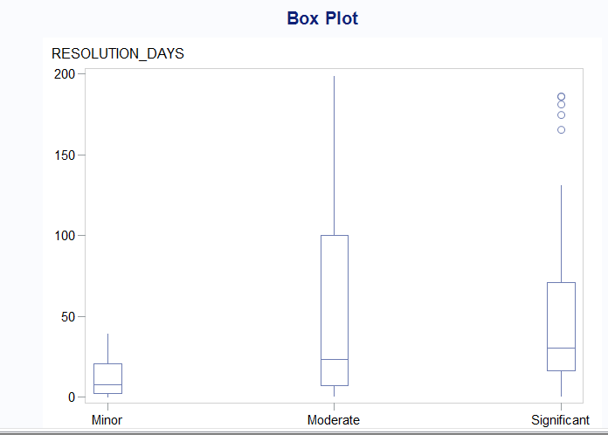

Note :- Some Service Requests have very long time to closure

/* CHECK DISTRIBUTION THRU TASKS > DESCRIBE > SUMMARY STATISTICS */

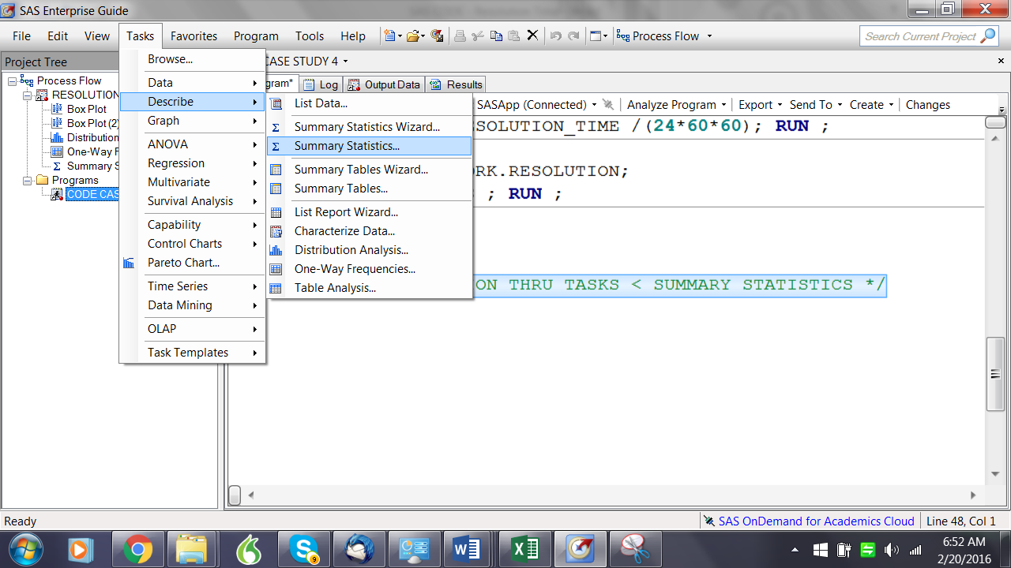

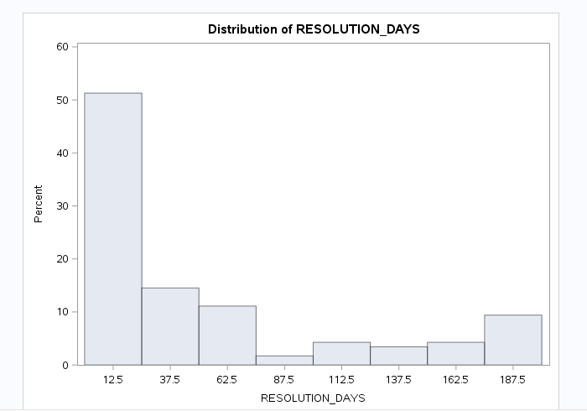

Note :- Most of the values have a resolution time of <=100 days.

/*C & O - COLLECT AND ORGANISE THE DATA

CHECK FOR MISSING VALUES */

**PROC** **MEANS** DATA=WORK.RESOLUTION; **RUN** ;

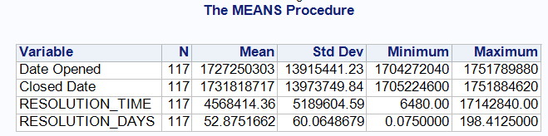

**PROC** **FREQ** DATA=WORK.RESOLUTION ;

TABLES Billable

Entitlement

Impact

'SR Type'N; **RUN** ;

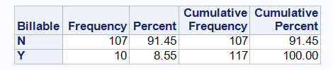

| **Entitlement** | **Frequency** | **Percent** | **Cumulative Frequency** | **Cumulative Percent** |
| --- | --- | --- | --- | --- |
| Operations & Alarm Management - BGP - 14 | 1 | 1.39 | 1 | 1.39 |
| Preventive Maintenance - 1 | 1 | 1.39 | 2 | 2.78 |
| Preventive Maintenance - 15 | 2 | 2.78 | 4 | 5.56 |
| Preventive Maintenance - 3 | 1 | 1.39 | 5 | 6.94 |
| Process History & Analytics - BGP - 7 | 1 | 1.39 | 6 | 8.33 |
| Process Optimization - BGP | 1 | 1.39 | 7 | 9.72 |
| Process Optimization - BGP - 1 | 1 | 1.39 | 8 | 11.11 |
| Process Optimization - BGP - 15 | 2 | 2.78 | 10 | 13.89 |
| Process Optimization - BGP - 18 | 1 | 1.39 | 11 | 15.28 |
| Process Optimization - BGP - 2 | 1 | 1.39 | 12 | 16.67 |
| Process Optimization - BGP - 7 | 2 | 2.78 | 14 | 19.44 |
| Requested Services - Fulfilment | 14 | 19.44 | 28 | 38.89 |
| Requested Services - Fulfilment - 1 | 1 | 1.39 | 29 | 40.28 |
| Requested Services - Fulfilment - 2 | 7 | 9.72 | 36 | 50.00 |
| Requested Services - Fulfilment - 3 | 4 | 5.56 | 40 | 55.56 |
| Requested Services - Incident Support - 1 | 6 | 8.33 | 46 | 63.89 |
| Requested Services Hiway Care Full - Fulfilment - 25 | 3 | 4.17 | 49 | 68.06 |
| Requested Services SESP Basic - Fulfilment - 5 | 1 | 1.39 | 50 | 69.44 |
| Requested Services SESP Basic - Fulfilment - 8 | 1 | 1.39 | 51 | 70.83 |
| Requested Services SESP Basic - Incident Support - 5 | 1 | 1.39 | 52 | 72.22 |
| Requested Services SESP Basic - Problem Management - 52 | 11 | 15.28 | 63 | 87.50 |
| Requested Services SESP Remote - Fulfilment - 13 | 8 | 11.11 | 71 | 98.61 |
| Requested Services SESP Remote - Incident Support - 5 | 1 | 1.39 | 72 | 100.00 |
| **Frequency Missing = 45** | | | | |

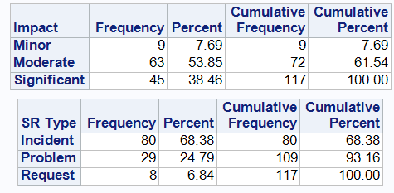

Note :- 45 Observations missing for Entitlement. All other variables have no missing values.

/* NO NEED TO CHECK SR number - WHICH IS THE PRIMARY KEY */

/*WE CAN CHECK FOR DUPLICATES IN PRIMARY KEY*/

**PROC** **SORT** DATA=WORK.RESOLUTION NODUPKEY OUT=WORK.RESOLUTION1;

BY 'SR number'N; **RUN**

Check in the log tab for details :-



# OUTLIERS FOR CONTINUOUS VARIABLE -RESOLUTION TIME

/* OUTLIERS FOR RESOLUTION TIME – TOP 1% OF THE VALUES */

|  |  |  |  |  |  |  |  |  |  |  |  |  |  |  |  |  |  |  |  |  |  |  |  |  |  |  |  |  |  |  |  |  |  |  |  |  |  |  |  |  |  |  |  |  |  |  |  |  |  |  |  |  |  |  |  |  |  |  |  |  |  |  |  |  |  |  |  |  |  |  |  |  |  |  |  |  |  |  |  |  |  |  |  |  |  |  |  |  |  |  |  |  |  |  |  |  |  |  |  |  |  |  |  |  |  |  |  |  |  |  |  |  |  |  |  |  |  |  |  |  |  |  |  |  |  |  |  |  |  |  |  |  |  |  |  |  |  |  |  |  |  |  |  |  |
| --- | --- | --- | --- | --- | --- | --- | --- | --- | --- | --- | --- | --- | --- | --- | --- | --- | --- | --- | --- | --- | --- | --- | --- | --- | --- | --- | --- | --- | --- | --- | --- | --- | --- | --- | --- | --- | --- | --- | --- | --- | --- | --- | --- | --- | --- | --- | --- | --- | --- | --- | --- | --- | --- | --- | --- | --- | --- | --- | --- | --- | --- | --- | --- | --- | --- | --- | --- | --- | --- | --- | --- | --- | --- | --- | --- | --- | --- | --- | --- | --- | --- | --- | --- | --- | --- | --- | --- | --- | --- | --- | --- | --- | --- | --- | --- | --- | --- | --- | --- | --- | --- | --- | --- | --- | --- | --- | --- | --- | --- | --- | --- | --- | --- | --- | --- | --- | --- | --- | --- | --- | --- | --- | --- | --- | --- | --- | --- | --- | --- | --- | --- | --- | --- | --- | --- | --- | --- | --- | --- | --- | --- | --- | --- | --- |
| |  |  |  |  |  |  |  |  |  |  |  |  |  |  |  |  |  |  |  |  |  |  |  |  |  |  |  |  |  |  |  |  |  |  |  |  |  |  |  |  |  |  |  |  |  |  |  |  |  |  |  |  |  |  |  |  |  |  |  |  |  |  |  |  |  |  |  |  |  |  |  |  |  |  |  |  |  |  |  |  |  |  |  |  |  |  |  |  |  |  |  |  |  |  |  |  |  |  |  |  |  |  |  |  |  |  |  |  |  |  |  |  |  |  |  |  |  |  |  |  |  |  |  |  |  |  |  |  |  |  |  |  |  |  |  |  |  |  |  |  |  |  |  |  | | --- | --- | --- | --- | --- | --- | --- | --- | --- | --- | --- | --- | --- | --- | --- | --- | --- | --- | --- | --- | --- | --- | --- | --- | --- | --- | --- | --- | --- | --- | --- | --- | --- | --- | --- | --- | --- | --- | --- | --- | --- | --- | --- | --- | --- | --- | --- | --- | --- | --- | --- | --- | --- | --- | --- | --- | --- | --- | --- | --- | --- | --- | --- | --- | --- | --- | --- | --- | --- | --- | --- | --- | --- | --- | --- | --- | --- | --- | --- | --- | --- | --- | --- | --- | --- | --- | --- | --- | --- | --- | --- | --- | --- | --- | --- | --- | --- | --- | --- | --- | --- | --- | --- | --- | --- | --- | --- | --- | --- | --- | --- | --- | --- | --- | --- | --- | --- | --- | --- | --- | --- | --- | --- | --- | --- | --- | --- | --- | --- | --- | --- | --- | --- | --- | --- | --- | --- | --- | --- | --- | --- | --- | --- | --- | | |  |  | | --- | --- | | |  | | --- | | **The UNIVARIATE Procedure Variable:  RESOLUTION_DAYS** | | | |  |  |  |  |  |  |  |  |  |  |  |  |  |  |  |  |  |  |  |  |  |  |  |  |  |  |  |  |  | | --- | --- | --- | --- | --- | --- | --- | --- | --- | --- | --- | --- | --- | --- | --- | --- | --- | --- | --- | --- | --- | --- | --- | --- | --- | --- | --- | --- | --- | | | **Moments** | | | | | --- | --- | --- | --- | | N | 117 | Sum Weights | 117 | | Mean | 52.8751662 | Sum Observations | 6186.39444 | | Std Deviation | 60.0648679 | Variance | 3607.78836 | | Skewness | 1.26515175 | Kurtosis | 0.19770147 | | Uncorrected SS | 745610.084 | Corrected SS | 418503.45 | | Coeff Variation | 113.597502 | Std Error Mean | 5.552999 | | | | **Basic Statistical Measures** | | | | | --- | --- | --- | --- | | **Location** | | **Variability** | | | Mean | 52.87517 | Std Deviation | 60.06487 | | Median | 23.68611 | Variance | 3608 | | Mode | . | Range | 198.33750 | |  |  | Interquartile Range | 61.99722 | | | | **Tests for Location: Mu0=0** | | | | | | --- | --- | --- | --- | --- | | **Test** | **Statistic** | | **p Value** | | | Student's t | t | 9.521912 | Pr > |t| | <.0001 | | Sign | M | 58.5 | Pr >= |M| | <.0001 | | Signed Rank | S | 3451.5 | Pr >= |S| | <.0001 | | | | **Quantiles (Definition 5)** | | | --- | --- | | **Level** | **Quantile** | | 100% Max | 198.41250 | | 99% | 191.93264 | | 95% | 185.97639 | | 90% | 167.46806 | | 75% Q3 | 70.97014 | | 50% Median | 23.68611 | | 25% Q1 | 8.97292 | | 10% | 4.88819 | | 5% | 2.17847 | | 1% | 0.95000 | | 0% Min | 0.07500 | | | | **Extreme Observations** | | | | | --- | --- | --- | --- | | **Lowest** | | **Highest** | | | **Value** | **Obs** | **Value** | **Obs** | | 0.075000 | 45 | 186.037 | 26 | | 0.950000 | 96 | 187.228 | 103 | | 0.979861 | 30 | 189.392 | 3 | | 1.027083 | 51 | 191.933 | 35 | | 1.096528 | 56 | 198.413 | 84 | | | | |

/* REMOVE VALUES GREATER THAN 191.93*/

**DATA** WORK.RESOLUTION ;

SET WORK.RESOLUTION ;

WHERE RESOLUTION_DAYS LE **191.93**; **RUN** ;

/* A - ANALYSE ; USE EMERICAL RULE AND CHEBYCHEV'S THEOREM ;

NEED CHECK DISTRIBUTION BY IMPACT*/

**PROC** **SORT** DATA=WORK.RESOLUTION ;

BY IMPACT; **RUN** ;

**PROC** **MEANS** DATA=WORK.RESOLUTION N MEAN MEDIAN STDDEV MIN MAX;

BY IMPACT ;

VAR RESOLUTION_DAYS; **RUN** ;

|  |  |  |  |  |  |  |  |  |  |  |  |  |  |  |  |  |  |  |  |  |  |  |  |  |  |  |  |  |  |  |  |  |  |  |  |  |  |  |  |  |  |  |  |  |  |  |  |  |  |  |  |  |  |  |  |  |  |  |  |  |  |  |  |  |  |  |  |  |  |  |  |  |
| --- | --- | --- | --- | --- | --- | --- | --- | --- | --- | --- | --- | --- | --- | --- | --- | --- | --- | --- | --- | --- | --- | --- | --- | --- | --- | --- | --- | --- | --- | --- | --- | --- | --- | --- | --- | --- | --- | --- | --- | --- | --- | --- | --- | --- | --- | --- | --- | --- | --- | --- | --- | --- | --- | --- | --- | --- | --- | --- | --- | --- | --- | --- | --- | --- | --- | --- | --- | --- | --- | --- | --- | --- |
| |  |  |  |  |  |  |  |  |  |  |  |  |  |  |  |  |  |  |  |  |  |  |  |  | | --- | --- | --- | --- | --- | --- | --- | --- | --- | --- | --- | --- | --- | --- | --- | --- | --- | --- | --- | --- | --- | --- | --- | --- | | |  |  |  | | --- | --- | --- | | |  | | --- | | **The MEANS Procedure** | | **Impact=Minor** | | | |  |  |  |  |  |  |  |  |  |  |  |  |  |  |  |  |  |  |  | | --- | --- | --- | --- | --- | --- | --- | --- | --- | --- | --- | --- | --- | --- | --- | --- | --- | --- | --- | | | **Analysis Variable : RESOLUTION_DAYS** | | | | | | | --- | --- | --- | --- | --- | --- | | **N** | **Mean** | **Median** | **Std Dev** | **Minimum** | **Maximum** | | 9 | 13.1111111 | 8.0458333 | 12.8386053 | 0.0750000 | 39.1416667 | | | | | |  |  | | --- | --- | | |  | | --- | | **Impact=Moderate** | | | | |  |  |  |  |  |  |  |  |  |  |  |  |  |  |  |  |  |  |  |  | | --- | --- | --- | --- | --- | --- | --- | --- | --- | --- | --- | --- | --- | --- | --- | --- | --- | --- | --- | --- | | |  |  |  |  |  |  |  |  |  |  |  |  |  |  |  |  |  |  |  | | --- | --- | --- | --- | --- | --- | --- | --- | --- | --- | --- | --- | --- | --- | --- | --- | --- | --- | --- | | | **Analysis Variable : RESOLUTION_DAYS** | | | | | | | --- | --- | --- | --- | --- | --- | | **N** | **Mean** | **Median** | **Std Dev** | **Minimum** | **Maximum** | | 61 | 53.8889572 | 21.2569444 | 61.6009313 | 0.9500000 | 189.3916667 | | | | | |  |  | | --- | --- | | |  | | --- | | **Impact=Significant** | | | | |  |  |  |  |  |  |  |  |  |  |  |  |  |  |  |  |  |  |  |  | | --- | --- | --- | --- | --- | --- | --- | --- | --- | --- | --- | --- | --- | --- | --- | --- | --- | --- | --- | --- | | |  |  |  |  |  |  |  |  |  |  |  |  |  |  |  |  |  |  |  | | --- | --- | --- | --- | --- | --- | --- | --- | --- | --- | --- | --- | --- | --- | --- | --- | --- | --- | --- | | | **Analysis Variable : RESOLUTION_DAYS** | | | | | | | --- | --- | --- | --- | --- | --- | | **N** | **Mean** | **Median** | **Std Dev** | **Minimum** | **Maximum** | | 45 | 53.1293981 | 30.3618056 | 55.3275387 | 0.9798611 | 186.0368056 | | | | |

/* CREATE SUBSETS ON TYPE OF IMPACT*/

**DATA** WORK.RESOLUTION_MINOR;

SET WORK.RESOLUTION;

WHERE IMPACT ='Minor'; **RUN** ;

**DATA** WORK.RESOLUTION_MOD;

SET WORK.RESOLUTION;

WHERE IMPACT ='Moderate'; **RUN** ;

**DATA** WORK.RESOLUTION_SIG;

SET WORK.RESOLUTION;

WHERE IMPACT ='Significant'; **RUN** ;

/* KEEP VALUES WHERE RESOLUTION_DAYS IS LE MEAN+2 SD*/

**DATA** WORK.RESOLUTION_MOD;

SET WORK.RESOLUTION_MOD;

WHERE RESOLUTION_DAYS LE (**53.8889572**+**2**\***61.6009313**); **RUN** ;

**DATA** WORK.RESOLUTION_SIG;

SET WORK.RESOLUTION_SIG;

WHERE RESOLUTION_DAYS LE (**53.1293981**+**2**\***55.3275387**); **RUN** ;

**PROC** **MEANS** DATA=WORK.RESOLUTION_MOD;

VAR RESOLUTION_DAYS; **RUN** ;

**PROC** **MEANS** DATA=WORK.RESOLUTION_SIG;

VAR RESOLUTION_DAYS; **RUN** ;

/* PROC MEANS FOR THE 3 SEGMENTS*/

**PROC** **MEANS** DATA=WORK.RESOLUTION_SIG;

VAR RESOLUTION_DAYS; **RUN** ;

**PROC** **MEANS** DATA=WORK.RESOLUTION_MOD;

VAR RESOLUTION_DAYS; **RUN** ;

**PROC** **MEANS** DATA=WORK.RESOLUTION_MINOR;

VAR RESOLUTION_DAYS; **RUN** ;

|  |  |  |  |  |  |  |  |  |  |  |  |  |  |  |  |  |  |  |  |  |
| --- | --- | --- | --- | --- | --- | --- | --- | --- | --- | --- | --- | --- | --- | --- | --- | --- | --- | --- | --- | --- |
| |  |  |  |  |  |  |  |  |  |  |  |  |  |  |  |  |  |  |  |  | | --- | --- | --- | --- | --- | --- | --- | --- | --- | --- | --- | --- | --- | --- | --- | --- | --- | --- | --- | --- | | |  |  | | --- | --- | | |  | | --- | | **The MEANS Procedure** | | | |  |  |  |  |  |  |  |  |  |  |  |  |  |  |  |  | | --- | --- | --- | --- | --- | --- | --- | --- | --- | --- | --- | --- | --- | --- | --- | --- | | | **Analysis Variable : RESOLUTION_DAYS** | | | | | | --- | --- | --- | --- | --- | | **N** | **Mean** | **Std Dev** | **Minimum** | **Maximum** | | 40 | 37.4316667 | 34.2218396 | 0.9798611 | 131.0465278 | | | | |

|  |  |  |  |  |  |  |  |  |  |  |  |  |  |  |  |  |  |  |  |  |
| --- | --- | --- | --- | --- | --- | --- | --- | --- | --- | --- | --- | --- | --- | --- | --- | --- | --- | --- | --- | --- |
| |  |  |  |  |  |  |  |  |  |  |  |  |  |  |  |  |  |  |  |  | | --- | --- | --- | --- | --- | --- | --- | --- | --- | --- | --- | --- | --- | --- | --- | --- | --- | --- | --- | --- | | |  |  | | --- | --- | | |  | | --- | | **The MEANS Procedure** | | | |  |  |  |  |  |  |  |  |  |  |  |  |  |  |  |  | | --- | --- | --- | --- | --- | --- | --- | --- | --- | --- | --- | --- | --- | --- | --- | --- | | | **Analysis Variable : RESOLUTION_DAYS** | | | | | | --- | --- | --- | --- | --- | | **N** | **Mean** | **Std Dev** | **Minimum** | **Maximum** | | 56 | 42.1649802 | 49.3103093 | 0.9500000 | 167.4680556 | | | | |

|  |  |  |  |  |  |  |  |  |  |  |  |  |  |  |  |  |  |  |  |  |
| --- | --- | --- | --- | --- | --- | --- | --- | --- | --- | --- | --- | --- | --- | --- | --- | --- | --- | --- | --- | --- |
| |  |  |  |  |  |  |  |  |  |  |  |  |  |  |  |  |  |  |  |  | | --- | --- | --- | --- | --- | --- | --- | --- | --- | --- | --- | --- | --- | --- | --- | --- | --- | --- | --- | --- | | |  |  | | --- | --- | | |  | | --- | | **The MEANS Procedure** | | | |  |  |  |  |  |  |  |  |  |  |  |  |  |  |  |  | | --- | --- | --- | --- | --- | --- | --- | --- | --- | --- | --- | --- | --- | --- | --- | --- | | | **Analysis Variable : RESOLUTION_DAYS** | | | | | | --- | --- | --- | --- | --- | | **N** | **Mean** | **Std Dev** | **Minimum** | **Maximum** | | 9 | 13.1111111 | 12.8386053 | 0.0750000 | 39.1416667 | | | | |

INSIGHT :-

1. The average Resolution Time varies significantly by IMPACT
2. The SLA can be derived using Chebychev’s theorem and Empirical Rule :-
   1. For Significant Impact cases
      1. By Checbyshev’s theorem
         1. Atleast 75% of the cases get resolved between 0 – 106 days
         2. Atleast 88.89% of the cases get resolved between 0-140 days
      2. By Emperical Rule
         1. 95% of the cases get resolved between 0 – 105.87 days
         2. 99.97% of the cases get resolved between 0-140 days
   2. For Moderate Impact cases
      1. By Checbyshev’s theorem
         1. Atleast 75% of the cases get resolved between 0 – 140 days
         2. Atleast 88.89% of the cases get resolved between 0-190 days
      2. By Emperical Rule
         1. 95% of the cases get resolved between 0 – 140 days
         2. 99.97% of the cases get resolved between 0-190 days

Work to do :- Define the significant ranges where IMPACT is Minor